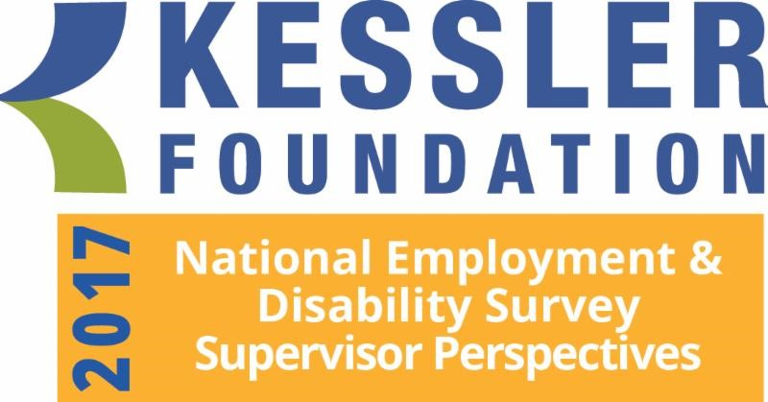

Report of Main Findings

Kessler Foundation
East Hanover, NJ
October 2017

Conducted by the
University of New Hampshire
Institute on Disability
Durham, NH

Prepared by

Kimberly G. Phillips, Ph.D.
Project Director, Institute on Disability, UNH

Andrew J. Houtenville, Ph.D.
Associate Professor of Economics and
Research Director, Institute on Disability, UNH

John O’Neill, Ph.D., CRC
Director, Employment and Disability Research, Kessler Foundation

Elaine E. Katz, M.S., CCC-SLP
Senior VP of Grants and Communications, Kessler Foundation

Suggested Citation:

Kessler Foundation (2017). Report of Main Findings from the Kessler Foundation 2017 National Employment and Disability Survey: Supervisor Perspectives. East Hanover, NJ.
Table of Contents

Executive Summary 3
Introduction 6
Objectives and Approach 7
Methods 8
Survey and Questionnaire Design 8
Data Collection 10
Participants 10
Employment Characteristics 11
Survey Findings 12
Recruiting Qualified Applicants 13
Hiring New Employees 14
Training New Hires 16
Providing Accommodations for Employees with Disabilities 19
Employee Retention 22
Conclusion 24
Closing Remarks 25
Appendix I: Demographic and Socioeconomic Characteristics of Survey Participants 26
Appendix II: Employment Characteristics of Survey Participants 28
Appendix III: References 30

2017 Kessler Foundation National Employment and Disability Survey:

Supervisor Perspectives

Executive Summary

Synopsis. The key findings of the 2017 Kessler Foundation National Employment and Disability Survey: Supervisor Perspectives (KFNEDS:SP) show that employers are striving to recruit, hire, train, and retain people with disabilities in their organizations. Supervisors provided information about the most-used employer practices, the most effective practices, and emerging practices that show promise of improving employment for people with disabilities.

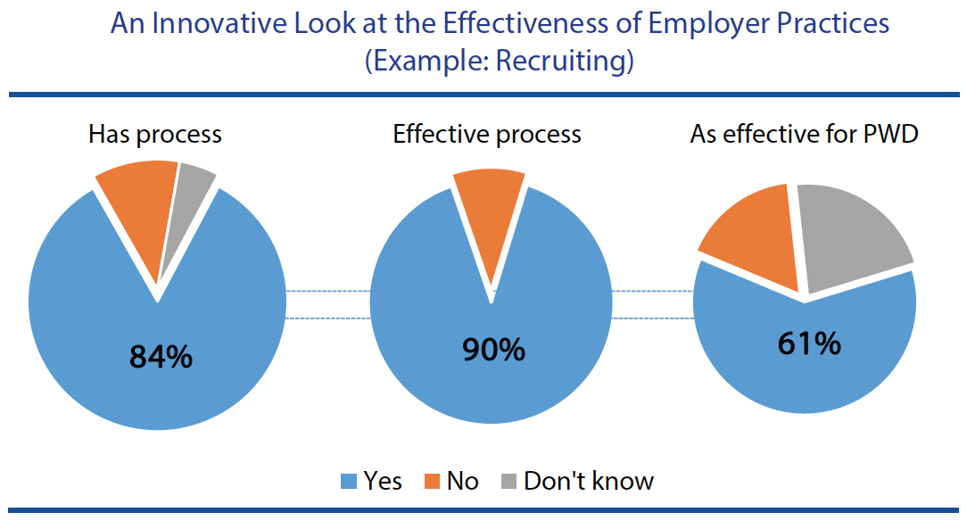

Objective. The innovative design of the 2017 KFNEDS:SP focused on identifying effective processes and practices that employers use to employ people with disabilities. This design asked if the organization used a practice, and if so, whether it was effective, and then, whether the practice was as effective with regard to people with disabilities. The design also delved inside organizational perspectives about employing people with disabilities—asking supervisors about the commitment of upper management relative to their own perspectives.

The 2017 KFNEDS:SP, conducted by the University of New Hampshire (UNH),

- addressed challenges common to employer-focused research by surveying supervisors on their own time, rather than while they are at work, allowing them to maintain their organizations’ anonymity, their personal anonymity, and avoiding pressure to respond in “socially desirable” ways, and

- generated actionable information to support the adoption of promising practices across the country in order to positively influence employment outcomes for Americans with disabilities.

Methods. The 2017 KFNEDS:SP was conducted using standard, replicable survey practices. From July 24 through August 4, 2017, a sample of supervisors from U.S. employers was invited to take the survey as part of Qualtrics and partners business-to-business (B2B) panel. More than 5,000 respondents (n = 5,231) ages 18 and older consented to participate in accordance with University of New Hampshire Institutional Review Board procedures. Of those, 687 were dropped because their organizations employed fewer than 25 people. Another 381 were removed for not supervising any direct reports in their current position, and 33 were dropped for indicating that they either did not understand the definition of disability as presented, or did not wish to continue the survey. An additional 1,034 were dropped for inattentive or rushed responding. Completed surveys were available from 3,096 respondents. Of those, 11 were removed by the researchers for incomplete responses on key demographic variables. The final analytic sample was 3,085 supervisors ages 18 and older working in the U.S. for organizations that employed 25 people or more employees.

Commitment of Upper Management. One of the key findings of 2017 KFNEDS:SP is that the importance supervisors give to hiring people with disabilities (22 percent feel it is very important) mirrors their perception of upper management’s commitment to hiring people with disabilities (20 percent are seen as very committed). In contrast, supervisors attach much more importance to helping employees with disabilities learn their jobs (78 percent of supervisors feel it is very important, while 43 percent of upper managers are seen as very committed). Similarly, when asked about providing employees with requested accommodations, 66 percent of supervisors feel it is very important, while 47 percent of upper managers are seen as very committed. Taken together, these results suggest that, while many in an organization may support the goal of hiring people with disabilities, when it comes to the details of realizing that goal, there may be less commitment and support than needed from upper management.

Organizational Processes. Another important set of findings is that most supervisors (84 percent) report that their organizations have established processes for recruiting and training employees. Of the organizations that have a standard recruiting process, in general, most supervisors (90 percent) believe it to be effective, but fewer (61 percent) feel that this recruiting process is as effective for recruiting employees with disabilities. Supervisors also suggest that organizations spend considerably less effort recruiting people with disabilities. Only 28 percent of organizations have disability hiring goals, while 57 percent have hiring goals for other types of diversity.

Of the organizations that have a process to help new employees learn their jobs (86 percent), most supervisors (93 percent) believe the process is effective for employees in general, but fewer (73 percent) feel that process is as effective for employees with disabilities

Many employers (66 percent) also have a process to provide requested accommodations to employees with disabilities. Nearly all supervisors (96 percent) believe the process is effective, suggesting an opportunity to provide support for the 34 percent of organizations who would benefit by having an accommodation process in place. Few organizations (16 percent) have a centralized accommodations fund, but when they do, most supervisors (94 percent) feel it is effective at improving their ability to provide requested accommodations to employees.

Specific Employer Practices. Findings from the 2017 KFNEDS:SP also suggest several opportunities to engage employers about specific practices that supervisors find effective for improving their ability to employ or accommodate people with disabilities. Some practices are both widespread and effective. For example, most organizations use job shadowing (66 percent) and onsite training by supervisors and co-workers (73 percent) as ways to help new employees learn their jobs. Almost all supervisors (97 percent) report that onsite training by supervisors or co-workers is effective for training employees, in general, and many supervisors feel it is as effective (81 percent) for training employees with disabilities.

Other practices are used by relatively few employers, but many supervisors who do use them also find them as effective for employees both with and without disabilities. For example, 13 percent of supervisors reported that their organizations offer job sharing as a flexible working arrangement for all employees. Nearly all of the supervisors (95 percent) said job sharing was effective for employees in general, and 92 percent felt it was as effective for employees with disabilities. Moreover, supervisors from organizations that do not use practices such as job sharing indicate that these practices would be feasible to implement at their workplaces. Of the 57 percent of supervisors from organizations that did not allow job sharing, 48 percent felt it would be feasible to implement this practice.

Closing Comments. This Executive Summary highlights the major findings of the 2017 KFNEDS:SP. Many more analyses are planned for these data, which will add to our understanding of the factors contributing to the employment of people with disabilities.

Introduction

Kessler Foundation, in partnership with the University of New Hampshire, conducted the 2017 National Employment and Disability Survey: Supervisor Perspectives (KFNEDS:SP) to identify the practices used by employers to increase the employment of people with disabilities and to understand supervisors’ views about the effectiveness of these practices.
Employers stand to enhance their workforce, increase profitability, and exhibit organizational responsibility by expanding the number of people with disabilities that they employ (Houtenville & Kalargyrou, 2012). In addition, as shown in the 2015 Kessler Foundation National Employment and Disability Survey (KFNEDS), people with disabilities are striving to work and overcoming barriers to employment (Sundar et al., in press). However, despite these opportunities and potentialities, the employment-to-population ratio of people with disabilities remains low (32.5%), compared to that of people without disabilities (77.0%) (Kessler Foundation and University of New Hampshire, 2017).
Survey research on employer perspectives and practices has evolved over the years. Early research largely described employer attitudes and perceptions about employing people with disabilities (Dixon, Kruse, & Van Horn, 2003; Domzal, Houtenville, & Sharma, 2008; Taylor, Krane, & Orkis, 2010). Some studies focused on employer experience providing workplace accommodations and the perceived effectiveness of possible practices to increase the employment of people with disabilities (Bruyère, Erickson, & Horne, 2002). Little is known about the number of employers using such practices or the effectiveness of such practices, making it difficult to translate research findings in a meaningful and actionable manner that supports change on the part of employers. When asked about the effectiveness of practices, human resources professionals seldom perceive the practices they use as being ineffective (Erickson, von Schrader, Bruyère, & VanLooy, 2014). Furthermore, practices studied in the past were only those that focused exclusively on workers with disabilities, ignoring general employment practices and how those practices may be differentially effective for workers with and without disabilities.
The 2017 KFNEDS:SP builds upon past research, using an innovative design to identify effective practices. The survey asked whether the organization used a practice, and if so, whether it was effective. When a practice applies to both people with and without disabilities, the survey asked whether the practice was as effective with regard to people with disabilities. In order to gauge the potential uptake of a practice when not in use, respondents whose organizations did not utilize a given practice were asked whether it would be feasible to implement. The survey also delved inside organizational perspectives about employing people with disabilities, asking supervisors about the commitment of upper management relative to their own perspectives.

Objectives and Approach

Two years ago, the 2015 Kessler Foundation National Employment and Disability Survey (KFNEDS) revealed the ways workers with disabilities strive to work by overcoming barriers. Similarly, the 2017 KFNEDS:SP utilizes innovative approaches to identify the ways employers strive to employ people with disabilities. The primary objectives of the 2017 KFNEDS:SP were to:
- understand the processes and practices employers use to recruit, hire, train, accommodate, and retain employees with disabilities;
- learn from supervisors’ perspectives about the effectiveness of employer practices related to the employment of people with disabilities; and
- generate actionable information to support the adoption of promising practices across the country in order to positively influence employment outcomes for Americans with disabilities.
The 2017 KFNEDS:SP represents a new approach to learning about employer practices. Formerly the standard method−the sampling of companies from Dun and Bradstreet listings− results in increasingly declining response rates and has typically been complicated by out-of-date phone numbers, incorrect contact persons, and difficulty reaching the person or persons most knowledgeable about disability-related practices. Additionally, there is the potential for privacy concerns when asking people about their organization when they have been specifically targeted as representatives of that organization, and for respondents to feel pressured to provide “socially desirable” responses. To overcome these challenges, the sample for the 2017 KFNEDS:SP was generated from a pre-screened panel of business respondents maintained by Qualtrics and its partners. Respondents were not asked to disclose their employers. Beyond the anonymity of the employers, supervisors contacted through this approach may be more likely to respond honestly, because the surveys were completed on their own time and not as a part of their paid workday.
Another benefit to this approach is that using a pre-screened panel dramatically reduces costs and allows for a much larger, more focused sample. By asking survey respondents about the strategies used at their organizations to support people with disabilities in their workplaces, the survey mode helped to overcome one of the largest barriers in disability research, which is to solicit information about employers. With its focus on processes and practices used and deemed effective, the 2017 KFNEDS:SP highlights feasible approaches to improve employers’ ability to successfully recruit, hire, accommodate, and retain qualified and talented employees with disabilities.

Methods

Survey and Questionnaire Design
The 2017 KFNEDS:SP was designed as an online survey of supervisors from U.S. organizations employing at least 25 workers, the minimum size of organizations responsible for complying with guidelines set forth by the Americans with Disabilities Act (ADA). The survey questionnaire was designed to ascertain supervisor perspectives about processes and practices used by their organizations to employ people with disabilities, and the effectiveness of those practices. The questionnaire was developed by researchers at the University of New Hampshire in consultation with Kessler Foundation and an advisory board. The survey protocol and procedures were approved by the University of New Hampshire Institutional Review Board.
The main topic areas covered by the survey included recruitment, hiring, onboarding, training, accommodation, and retention of employees. Within each topic area, supervisors were asked whether their organization had a process (e.g., “Do you have a process to recruit qualified employees?”). When indicating that a process was in place, supervisors were next asked if the process was effective, in general. If they felt the process was effective (i.e., “somewhat effective” or “very effective”), they were asked whether it was “as effective” for people with disabilities. In this way, information specific to employees with disabilities could be contextualized within the larger picture of the organizations’ overall effectiveness in relation to its employees.
Next, supervisors were asked to characterize upper management’s commitment to hiring, training, and retaining employees with disabilities. To contrast with their perspective on upper management’s commitment, similar items also asked how important each of these areas was to the supervisors themselves. This not only provided a context through which to contrast the relative importance or commitment to each outcome, but also served as a mechanism to reduce pressure on supervisors to respond in socially desirable ways by allowing them to distinguish their own beliefs from those they attributed to upper management.
Finally, the survey asked about specific practices that were in place at supervisors’ organizations (e.g., “reviewing hiring practices to determine their accessibility for people with disabilities,” “allowing job sharing,” “flexible work schedules”). Supervisors indicated whether each practice automatically applied to all employees in general, was used in the past or upon employee request (or at supervisors’ discretion), or not typically used. As with the process questions, follow-up items regarding effectiveness (both in general and specific to people with disabilities) were asked whenever a practice was reported. When a practice was not used by an organization, or if supervisors were not certain whether a practice was used, they reported whether or not they thought the practice would be “feasible” in order to improve employment of people with disabilities. In this way, the survey helps to identify promising practices as those that are perceived to be most effective by employers who have used them and most feasible by employers who have not.

Data Collection
The 2017 KFNEDS:SP was conducted using standard, replicable survey practices. Respondents of the survey included adults ages 18 and over who worked as supervisors in U.S. businesses and organizations. From July 24 through August 4, 2017, a sample of supervisors from employers around the country were invited to take the survey as part of Qualtrics and partners business-to-business (B2B) panel. Respondents were recruited by Qualtrics and its partner organizations using a variety of methods, including web intercept, targeted email lists, panel member referral, and social media. Incentives for respondents included cash payments, free downloads, and/or membership points; all incentives were decided and allocated by Qualtrics and its partners. Informed consent to participate was obtained in accordance with requirements of the University of New Hampshire Institutional Review Board. The median time to complete the survey was 14.6 minutes.

Participants
More than 5,000 respondents (n = 5,231) ages 18 and over consented to participate in the survey. Of those, 687 were dropped because their organization employed fewer than 25 people (and thus was not required to adhere to standards of the ADA). Another 381 respondents were removed for not supervising any direct reports in their current position, and 33 respondents were dropped for indicating that they either did not understand the definition of disability as presented or did not wish to continue the survey. An additional 1,034 respondents were dropped for inattentive or rushed responding. Completed surveys were available from 3,096 respondents. Of those, 11 respondents were removed by the researchers for incomplete responses on key demographic variables. The final analytic sample was 3,085 supervisors ranging in age from 18 to 78 and representing all 50 states.
Responses of the 3,085 supervisors were analyzed using Stata 15 (StataCorp, 2017). Of the 3,085 supervisors, 41 percent were male, and 48 percent were between the ages of 35 and 54. Most (76 percent) had a college degree or higher, and 60 percent earned at least $75,000 annually. White non-Hispanic respondents comprised 77 percent of the sample; 6 percent were Black non-Hispanic, and 9 percent were Hispanic. Respondents were presented with the federal definition of disability as stated in the ADA (U.S. Department of Justice, 2009). According to this definition, many of the supervisors surveyed had some personal experience with or exposure to disability: 18 percent experienced a disability themselves, and another 33 percent reported that someone close to them (e.g., family member, friend, colleague) had a disability. See Appendix I for detailed demographic and socioeconomic information on survey participants.

Employment Characteristics
Organizations of various sizes were represented in the survey results. Most (48 percent) were from organizations with 500 or more employees. Compared to recent data from the Census Bureau’s Statistics of U.S. Businesses (SUSB, 2013), the survey sample slightly overrepresented mid-sized organizations: 30 percent of respondents came from organization with 100 to 499 employees, compared to 16 percent nationally. The remaining 22 percent represented smaller organizations with 25 to 99 employees.
Most (69 percent) respondents worked for private for-profit organizations. Another 16 percent worked for non-profit organizations, and 15 percent were employed in the government sector. See Table 1. Supervisors who answered the survey came from a variety of industries. Besides the “other” category (23 percent), the most represented industries were health (13 percent), the service industry (12 percent), and education (11 percent). More detail is provided in Appendix II.

Table 1. Survey Participants’ Employment Sector and Industry
Sector |  | Percent | Industry | Percent
Private for-profit |  | 69 | Professional, scientific and technical | 11
Non-profit |  | 16 | Finance, insurance, and real estate | 9
Government |  | 15 | Administrative or support | 4
 | Federal | 4 | Service industry | 12
 | State | 7 | Education | 11
 | Local | 4 | Health | 13
 |  |  | Manufacturing | 10
 |  |  | Construction | 4
 |  |  | Agriculture, forestry, or fishing | 0.4
 |  |  | Other | 23
 |  |  | Don’t know | 0.6

More than half of the supervisors (61 percent) had been working at their current place of employment for 10 years or less, though 15 percent had been at their current employer more than 20 years. The majority (53 percent) had been in a supervisory role for 5 years or less. Half (50 percent) supervised 10 or fewer direct reports, though 22 percent reported supervising more than 20 employees.
Nearly all of the supervisors (90 percent) had hired at least one person; 44 percent had hired 10 or fewer new employees, and 19 percent had hired more than 50. As many as 58 percent indicated that they had hired at least one person with a disability; the average number of people with disabilities hired was 4.
Just over half of the supervisors (51 percent) had some experience supervising people with disabilities. Of these, supervisory experience with employees with hearing disabilities was reported by 20 percent; experience with employees who had vision difficulties by 9 percent; experience supervising individuals with mobility limitations was reported by 26 percent. Finally, 27 percent of respondents reported having experience supervising individuals with cognitive limitations (i.e., “due to a physical, mental or emotional problem, difficulty remembering, concentrating or making decisions”). See Appendix II for more detailed information on the employment characteristics of survey participants.

Survey Findings
The 2017 KFNEDS:SP asked supervisors about their employers’ processes, practices, and levels of commitment to employees as related to several topic areas, including recruitment, hiring, onboarding, training, accommodating, and retaining employees. Once processes and specific practices were revealed, a set of follow-up questions was then used to discover whether strategies and approaches that were in place were considered effective, both for employees, generally, and for employees with disabilities, specifically.

Recruiting Qualified Applicants
Figure 1 shows percentages of organizations with a process to recruit new employees and supervisors’ estimation of the effectiveness of these processes. Most organizations (84 percent) had a process for recruiting new employees, and in 90 percent of cases, the supervisors felt these processes were effective at attracting qualified applicants. Far fewer (61 percent) felt the processes were as effective for recruiting applicants with disabilities. This may be due to the fact that a minority of organizations expend “moderate” to “a lot” of effort on recruiting people with disabilities. Only 44 percent were reported to expend this amount of effort recruiting people with disabilities, compared to 69 percent who expend moderate to a lot of effort recruiting for diversity, and 74 percent who exert this amount of effort on recruiting, in general.

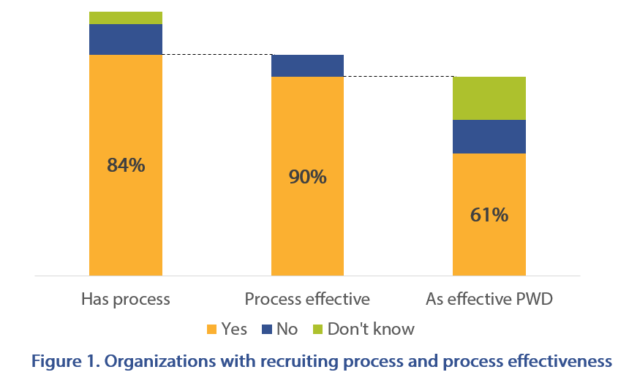
Recruiting practices. Supervisors were asked whether their organizations partner with disability organizations to help them recruit qualified people with disabilities. Only 27 percent answered affirmatively. Of those who do use this practice, almost all (95 percent) felt it was effective. Thirty-five percent of supervisors were not sure whether their organizations did this already, but of them, 85 percent believed it would be feasible to implement. Even a majority of supervisors whose companies do not partner with disability organizations to recruit (66 percent) agreed it would be feasible to do so in order to attract more qualified applicants with disabilities.

Hiring New Employees
Supervisors reported that, to some degree, upper management in their organizations was committed to hiring people with disabilities. As shown in Figure 2, about one-fifth (20 percent) of upper level managers were seen as “very committed” while another 45 percent were “somewhat committed.” Supervisors’ own importance attributed to hiring people with disabilities mirrored the commitment they saw from their management: 22 percent of supervisors reported it was “very important,” and 46 percent said it was “somewhat important.”
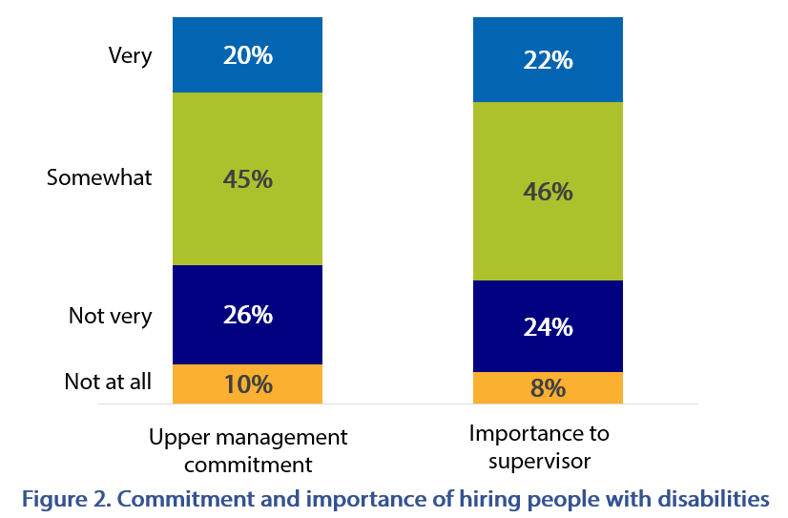
The generally low levels of strong commitment or importance given to hiring people with disabilities were reflected in the organizational hiring goals, as reported by supervisors. Only 28 percent had company goals to hire people with disabilities, although a majority (57 percent) reported diversity hiring goals. Of the 57 percent with diversity hiring goals, only 12 percent reported that people with disabilities were included as a diversity population.
Hiring practices. Supervisors were asked about specific employer practices related to hiring people with disabilities, and they provided information about the perceived effectiveness and feasibility of those practices. A summary of findings is provided in Table 2. Two hiring practices were seen by most as either effective, when used, or feasible, when not currently used.
Fewer than half (40 percent) of organizations represented were reported to provide training for supervisors in accessible application and interview techniques. Among those who used the practice, most (87 percent) felt it was effective for hiring people with disabilities. Among the 23 percent of supervisors who did not know whether their organizations offered training in accessible application and interview techniques, 83 percent felt it would be feasible to implement this practice. About two-thirds (67 percent) of supervisors whose organizations did not offer this training (37 percent did not) indicated that it would be a feasible strategy to make it easier for their organizations to hire qualified people with disabilities.
Table 2. Hiring Practices and Perceived Effectiveness (if used) or Feasibility (if not used)
 | Uses practice | Practice is effective | Would be feasible
 | Train supervisors in accessible application and interview techniques
Yes | 40% | 87% | --
No | 37% | -- | 67%
Don’t know | 23% | -- | 83%
 | Review or audit hiring procedures to ensure accessibility
Yes | 43% | 86% | --
No | 20% | -- | 64%
Don’t know | 37% | -- | 85%

Supervisors were also asked whether their organizations reviewed or audited hiring practices to ensure they were accessible to people with disabilities. Of the 43 percent whose organizations do this, 86 percent felt it was effective for hiring people with disabilities. Another 37 percent were not sure whether their organizations did this, although 85 percent of those supervisors felt it would be feasible to do so. Finally, of the 20 percent who said their organizations did not review the accessibility of their hiring practices, 64 percent felt it would be a feasible practice to implement.

Training New Hires
Most supervisors (86 percent) reported that their organizations had a process for supporting new hires to learn their jobs, and most (93 percent) who had a process felt it was effective. Almost three-quarters (73 percent) also indicated that the process for supporting new employees to learn their jobs was as effective for people with disabilities as it was for employees, in general. When organizations were reported not to have a process by which employees were supported to learn their jobs, supervisors were asked whether their “current practices” were effective. In contrast to those whose employers had a known process, fewer supervisors (57 percent) reported their current practices for supporting employees to learn their jobs were effective and, of those, fewer (59 percent) felt the support provided was as effective for new hires with disabilities.
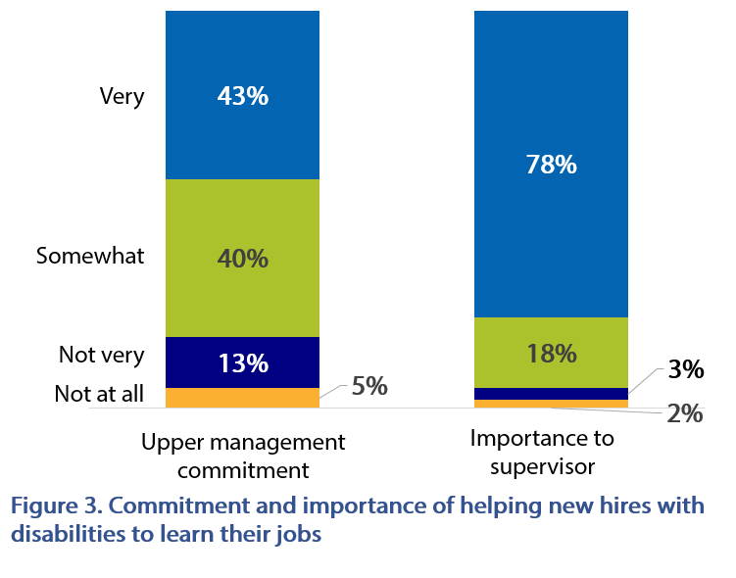
Figure 3 shows the perceived commitment of upper management and supervisors’ own attribution of importance to supporting employees with disabilities to learn their jobs. Although 43 percent of supervisors saw upper management at their organizations as being “very committed” to supporting employees with disabilities to learn their jobs, this is slightly less than the half (50 percent) who were very committed to supporting employees in general to learn their jobs. It is also substantially less commitment than supervisors themselves afforded to employees with disabilities to learn their jobs; 78 percent of respondents said it was “very important” to them as supervisors to support employees with disabilities to learn their jobs. Still, this figure is slightly lower than the 81 percent who indicated it was very important to support employees in general to learn their jobs.
Training practices. Table 3 summarizes organizations’ utilization of three specific training practices, as well as supervisors’ perspectives about their effectiveness (when used) or feasibility (when not used). Supervisors were asked whether their organizations offered certain practices to help new employees to learn their jobs, and they could select one of three responses. They could indicate that the practice was a) “automatically offered for all new hires,” b) “offered at supervisor discretion or upon new hire request,” or c) “not typically offered.”
Nearly three-quarters (73 percent) of organizations were reported to automatically offer all new employees onsite training by a supervisor or coworker as a way to help them to learn their jobs. Of those, an overwhelming majority (97 percent) found this to be an effective practice. Somewhat fewer, although still a large number (81 percent), of supervisors from these organizations reported onsite training by a supervisor or coworker to be as effective for helping employees with disabilities to learn their jobs.
The same pattern held for organizations that offered onsite training by supervisors or coworkers only upon employee request or at the supervisor’s discretion. Onsite training was sometimes used by 25 percent of respondents’ organizations; of those 82 percent found it effective, and 86 percent said it was as effective for employees with disabilities.
Job shadowing was reported by 61 percent of supervisors as being automatically offered to all new hires to help them learn their jobs. Of the 61 percent, nearly all (98 percent) found it effective, and of these, 80 percent felt it was as effective for employees with disabilities. Job shadowing was sometimes used at the organizations of 27 percent of supervisors. Again, most respondents (93 percent) found job shadowing to be effective, and 75 percent indicated that it was as effective for new hires with disabilities. Only 12 percent of supervisors said that their organizations did not typically offer job shadowing. Of those who didn’t use it, 70 percent felt it would be a feasible way to help new employees learn their jobs.
Table 3. Training Practices and Perceived Effectiveness (if used) or Feasibility (if not used)
 | Uses practice | Practice is effective | Would be feasible
 | Onsite training by supervisor or coworker
Yes | 73% | 97% | --
Sometimes | 22% | 94% | --
No | 5% | -- | 77%
 | Job shadowing
Yes | 61% | 98% | --
Sometimes | 27% | 93% | --
No | 12% | -- | 70%
 | Short-term outside assistance
Yes | 19% | 89% | --
Sometimes | 25% | 52% | --
No | 56% | -- | 70%

The third hiring practice supervisors reported about was offering short-term outside assistance, such as job coaching. This practice was the least used of the three, but where it was used, supervisors usually found it effective for employees, including employees with disabilities. Short-term outside assistance was automatically offered for all new hires at organizations represented by 19 percent of supervisors. Most (89 percent) found it to be an effective way to help new employees learn their jobs, and 86 percent of these indicated that it was as effective for new hires with disabilities. Similarly, of the 25 percent who sometimes offered short-term outside assistance, 82 percent found it effective. Of these, 86 percent said it was as effective for employees with disabilities.

Providing Accommodations for Employees with Disabilities
About two-thirds (66 percent) of supervisors reported that their organizations had a process for employees with disabilities to request accommodations such as specialized equipment, job reassignment, a modified work schedule, or extra assistance. When a process was in place, nearly all (96 percent) supervisors felt it was effective. It was less clear how employees were made aware of the process; only 59 percent reported that the process was discussed at a new employee orientation. Only 16 percent of supervisors said that their organizations had a centralized accommodation fund, a general account specifically to pay for applicant and employee accommodations. When organizations had such a fund, it was almost always (94 percent) viewed as an effective at improving the ability to provide accommodations to employees with disabilities when requested.
Providing requested accommodation was important to supervisors. Most (66 percent) indicated that it was “very important” and another 28 percent felt it was “somewhat important.” In comparison, supervisors perceived that upper management had a bit less commitment to providing employees with requested accommodations. Supervisors indicated that 47 percent of upper-level managers were “very committed” and 39 percent were “somewhat committed” to fulfilling accommodation requests. Only 6 percent of supervisors felt accommodations were “not very” or “not at all” important, compared to 14 percent of upper management who were seen as not committed to providing the same.
Accommodation practices. Supervisors were asked to report on three specific practices relating to flexible working arrangements, as these kinds of accommodations are widely available to employees with and without disabilities. As with training practices, accommodation practices were described as being automatically offered, offered at supervisor discretion or upon employee request, or not typically offered. When practices were not typically used, supervisors were asked whether those practices would be a feasible strategy to improve the organizations’ ability to employ people with disabilities. Table 4 shows organizations’ flexible working arrangements and their respective effectiveness for employees, generally, and employees with disabilities, specifically.
Table 4. Accommodation Practices re Flexible Working Arrangements and Perceived Effectiveness (if used) or Feasibility (if not used)
 | Uses practice | Effective | As effective PWD | Would be feasible
 | Flexible work schedule
Yes | 25% | 95% | 86% | --
Sometimes | 52% | 90% | 79% | --
No | 23% | -- | -- | 48%
 | Working from home (at least some of the time)
Yes | 18% | 85% | 87% | --
Sometimes | 38% | 74% | 69% | --
No | 45% | -- | -- | 21%
 | Job sharing
Yes | 13% | 95% | 92% | --
Sometimes | 37% | 86% | 84% | --
No | 57% | -- | -- | 48%

A flexible work schedule was reported by 25 percent of supervisors as an accommodation practice that was automatically available to all employees. Another 52 percent indicated that flexible work schedules could be offered at supervisor discretion or upon employee request. Where automatically offered, 95 percent of supervisors felt flexible work schedules were effective, and 86 percent of these indicated they were as effective for employees with disabilities. Slightly fewer (90 percent) supervisors whose organizations sometimes offered flexible work schedules agreed that this was an effective tool to maintain the productivity of employees, and 79 percent of those said it was as effective a tool for employees with disabilities. Among the 23 percent of supervisors whose organizations did not typically offer flexible work schedules, fewer than half (48 percent) felt it would be a feasible strategy to improve the organizations ability to employ people with disabilities.
Working from home was the second flexible working arrangement posed to supervisors as an accommodation practice. Figure 4 illustrates the results. Working from home was an option frequently offered by organizations: 18 percent of supervisors said their organizations automatically allowed employees to work from home at least some of the time, and another 38 percent said they allowed occasional or frequent working from home upon employee request or at the supervisors’ discretion. In total, 78 percent of supervisors whose organization offered working from home as an accommodation felt this practice was effective, including 85 percent of supervisors whose organization offered the practice automatically for all employees and 74 percent who offered it some of the time. A large proportion of respondents (45 percent) reported that working from home was not typically allowed. Of these, less than one-fourth (21 percent) felt allowing employees to work from home at least some of the time would be a feasible strategy to improve their ability to employ people with disabilities.
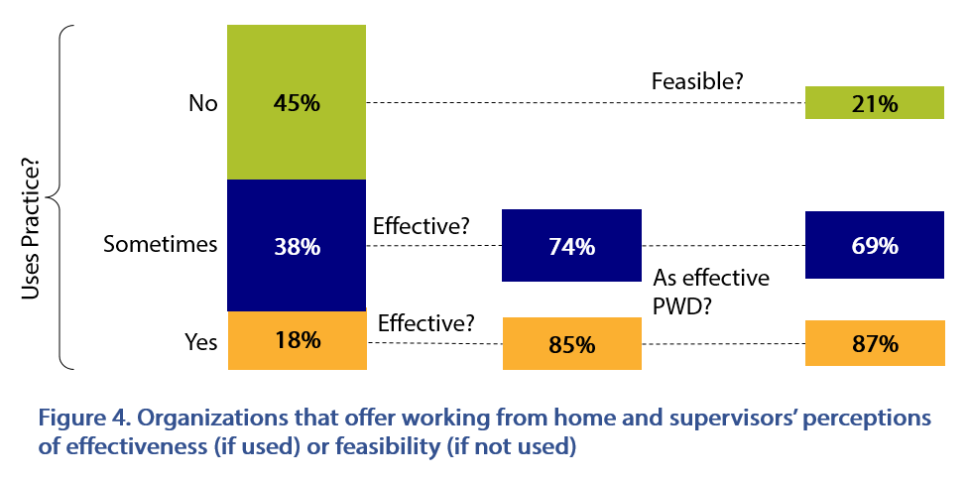
Job sharing was the third flexible working arrangement accommodation practice about which supervisors responded. Only 13 percent of supervisors reported that their organizations automatically offered job sharing, and 95 percent of those supervisors felt it was effective. Most (92 percent) considered job sharing at least as effective for employees with disabilities. Another 37 percent of supervisors said that job sharing was offered at the supervisor’s discretion or upon employee request. Of those, 86 percent felt it was an effective tool to maintain employee productivity, and 84 percent indicated that it was as effective for employees with disabilities. Among the 57 percent of organizations reported not to offer job sharing, just under half (48 percent) of supervisors felt it would be a feasible strategy to improve their organizations’ ability to employ people with disabilities.

Employee Retention

Table 3. Practices to Retain Employees with Disabilities and Perceived Effectiveness (if used) or Feasibility (if not used)
 | Uses practice | Practice is effective | Would be feasible
 | Train employees regarding disability issues and cultural competence
Regularly | 43% | 94% | --
In the past | 27% | 85% | --
No | 23% | -- | 80%
 | Consult guidance from federal, state, or local resources
Regularly | 40% | 94% | --
In the past | 34% | 85% | --
No | 26% | -- | 74%
Only 18 percent of supervisors reported that their organizations had a process that

allowed employees to anonymously disclose disabilities or health conditions. Another 30 percent indicated they were not certain whether there was a disclosure process in place, and the remaining majority (51 percent) said there was no process to anonymously disclose disabilities or health conditions. This is significant because disability disclosure often is a precursor to an inclusive workplace environment and an employer’s ability to provide useful accommodations for employees who need them (Charmaz, 2010; von Schrader, Malzer, & Bruyère, 2014).
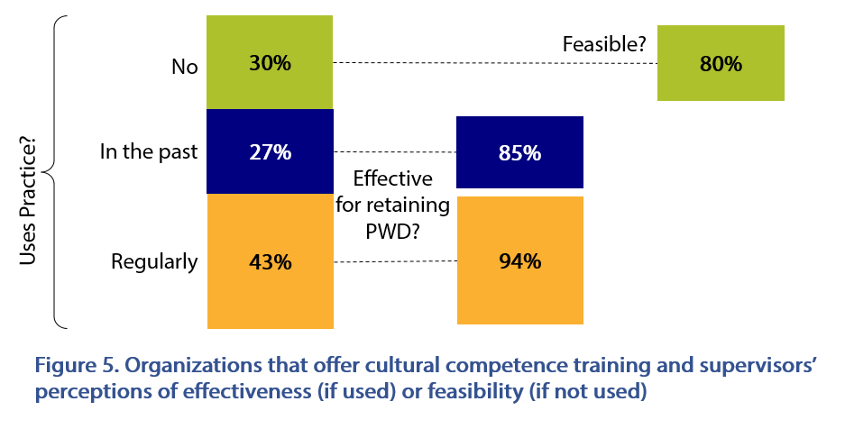
Retention practices. Commonly cited barriers to employment that people with disabilities face include negative attitudes, stigma, stereotypes, and assumptions on the part of supervisors and employers (Schur, Kruse, Blasi, & Blanck, 2009; Sundar et al., in press). Successful retention of employees with disabilities can be improved by addressing these barriers. As such, supervisors were asked whether their organizations offered training to employees about disability issues and cultural competence in order to improve knowledge and attitudes about colleagues with disabilities. Results are summarized in Table 3 and illustrated in Figure 5. Almost half (43 percent) reported that their organizations do this regularly, and 94 percent of those supervisors believed it was effective at improving the organization’s ability to employ or accommodate people with disabilities. Another 27 percent of supervisors indicated that their organizations had offered cultural competence with disability training in the past. Of those, 85 percent said it was effective. Only about one-third (30 percent) of supervisors’ organizations did not offer cultural competence training regarding disability issues, but 80 percent of those supervisors said it would be a feasible practice to implement.
Because retention and accommodation practices often are linked when it comes to employees with disabilities, supervisors were also asked whether they consult guidance from federal, state, or local resources regarding the provision of accommodations. This practice was regularly undertaken by 40 percent of supervisors’ organizations, and had been done in the past by another 34 percent. Among organizations that do this regularly, most (94 percent) supervisors believed that consulting guidance from federal, state, or local resources was an effective way to improve their organizations’ ability to employ or accommodate people with disabilities. Slightly fewer, although still a strong majority (85 percent), supervisors whose organizations had used this practice in the past also reported it was effective. Among the 26 percent of supervisors from organizations that did not use this practice, 74 percent felt it would be a feasible strategy to improve their ability to employ or accommodate people with disabilities.

Conclusion
The 2017 KFNEDS:SP was conducted to further our understanding of the processes and practices used by employers to increase the employment of people with disabilities and to discover, from the supervisor’s perspective, the effectiveness of these practices. The results show that employers are striving to recruit, hire, train, and retain people with disabilities and reveal areas of opportunity for even greater success. For example, the importance that supervisors give to hiring people with disabilities mirrors their perceived commitment of upper management to hire people with disabilities. However, compared to the perceived commitment of upper management, supervisors attach much more importance to helping employees learn their jobs and to providing employees with requested accommodations.
Most employers have processes in place for recruitment and training, and these processes are typically seen as effective for employees, generally, and employees with disabilities, specifically. Many (66 percent) employers also have a process to provide requested accommodations, and nearly all supervisors believe these processes are effective. This suggests an opportunity to support the 34 percent of supervisors’ organizations that do not have such a process.
Findings from the 2017 KFNEDS:SP also suggest opportunities to further investigate and engage employers regarding specific practices they undertake. Some practices are currently used by relatively few employers. However, these practices often are seen as effective by those who use them and feasible by those who do not. Examples include partnering with disability organizations to recruit qualified applicants with disabilities, utilizing short-term outside assistance (e.g., a job coach) to help employees with disabilities learn their jobs, and offering job sharing to make it easier to employ or accommodate people with disabilities.
Many more analyses are planned for the data collected from the KFNEDS:SP, which will add to our understanding of the factors contributing to the employment of people with disabilities. For example, what are the characteristics of employers (e.g., industry, company size) most successfully striving to employ people with disabilities? Answers to this and related research questions will inform future education efforts and the provision of support to employers and, along with findings in this report, will suggest which interventions may be most effective in which types of organizations.
The KFNEDS:SP also generated answers to many open-ended questions that delve deeper into supervisors’ perspectives and experiences working with people with disabilities. Qualitative data from these questions are likely to reveal emerging practices not yet fully recognized in the field of employment and disability. Updates on this report, as well as future results and publications, can be found at KesslerFoundation.org/kfsurvey17.

Closing Remarks
The 2017 KFNEDS:SP is the first national survey to look at the effectiveness of the practices that employers use to recruit, hire, train, and retain people with disabilities in their organizations, from the unique perspective of supervisors of employees with and without disabilities. The results offer important new information for employers, policymakers, legislators, and the disability community. Information about the utilization and effectiveness of workplace practices will engender new priorities, policies, and programs to educate and assist employers as they strive to expand practices with the greatest potential for improving employment outcomes of people with disabilities.

Appendix I: Demographic and Socioeconomic Characteristics of Survey Participants
Table A1-1. Sample Demographics and Socioeconomic Information with National Benchmarks from the U.S. Census
 |  | Survey Sample |  | U.S. Census
 |  | Number | Percent | Percent
Total |  | 3,085 | 100.0 | 100.0
Gender
 | Male | 1,264 | 41.0 | 50.0
 | Female | 1,821 | 59.0 | 50.0
Age
 | 18 to 34 | 847 | 27.5 | 31.9
 | 35 to 54 | 1,490 | 48.3 | 35.6
 | 55 to 79 | 748 | 24.2 | 32.5
Race (non-Hispanic) / Ethnicity
 | White | 2,373 | 77.1 | 63.7
 | Black | 196 | 6.4 | 12.2
 | American Indian / Alaska Native | 30 | 1.0 | 0.7
 | Asian | 134 | 4.4 | 4.7
 | Native Hawaiian / Pacific Islander | 6 | 0.2 | 0.2
 | Other | 23 | 0.7 | 0.2
 | Two or more races | 48 | 1.6 | 1.9
 | Hispanic | 268 | 8.7 | 16.3
 | Not answered | 7 | --
Education
 | Less than high school | 8 | 0.3 | 11.9
 | High school or equivalent | 153 | 5.0 | 26.8
 | Some college / technical school | 584 | 18.9 | 32.7
 | College degree | 1,361 | 44.1 | 18.7
 | Postgraduate | 979 | 31.7 | 9.9
Annual Household Income
 | Less than $15,000 | 15 | 0.5 | 16.9
 | $15,000 to 29,999 | 109 | 3.7 | 17.4
 | $30,000 to 44,999 | 248 | 8.3 | 14.2
 | $45,000 to 59,999 | 384 | 12.9 | 11.0
 | $60,000 to 74,999 | 425 | 14.2 | 8.6
 | $75,000 to 99,999 | 524 | 17.6 | 9.8
 | $100,000 and over | 1,277 | 42.8 | 22.1
Disability Status
 | Hearing difficulty¹ | 147 | 27.1 | 28.1
 | Vision difficulty¹ | 79 | 14.6 | 18.3
 | Ambulatory disability¹ | 198 | 36.5 | 52.4
 | Cognitive disability¹ | 225 | 41.5 | 49.1
 | Any of the 4 types² | 495 | 16.0 | 12.6
 | Other type of disability² | 47 | 1.5 | --
 | No disabilities² | 2,543 | 82.5 | 87.4
¹Sum is greater than sample size because people may have multiple disabilities.
²These three rows sum to the sample size (495+47+2,543 = 3,085, 100%).

Appendix II: Employment Characteristics of Survey Participants
Table A2-1. Sample Employment Characteristics with National Benchmarks from the U.S. Census
 |  | Survey Sample |  | U.S. Census
 |  | Number | Percent | Percent
Total |  | 3,085 | 100 | 100
Organization Size
 | 25 to 99 | 692 | 22.4 | 30.6
 | 100 to 499 | 910 | 29.5 | 16.0
 | 500 or more | 1,483 | 48.1 | 53.4
Industry
 | Professional, scientific, technical | 401 | 13.1 | 11.3
 | Finance, insurance, real estate | 278 | 9.1 | 2.1
 | Administrative or support | 111 | 3.6 | 4.6
 | Service industry | 369 | 12.0 | 9.8
 | Education | 344 | 11.2 | 9.2
 | Health | 408 | 13.3 | 13.8
 | Manufacturing | 314 | 10.3 | 10.3
 | Construction | 116 | 3.8 | 6.4
 | Agriculture, forestry, fishing | 13 | 0.4 | 1.9
 | Other | 712 | 23.2 | 16.4
 | Not answered | 19 | -- | --

Table A2-2. Additional Sample Employment Characteristics
 |  |  | Number |  | Percent
Total |  |  | 3,085 |  | 100
Employment Sector
 | Private for profit |  | 2,117 |  | 68.7
 | Non-profit |  | 504 |  | 16.4
 | Government |  | 459 |  | 14.9
 | Federal¹ |  | 121 |  | 3.9
 | State¹ |  | 213 |  | 6.9
 | Local¹ |  | 125 |  | 4.1
 | Not answered |  | 5 |  | --
Years at Current Employer
 | 5 or fewer |  | 989 |  | 32.1
 | 6 to 10 |  | 884 |  | 28.6
 | 11 to 20 |  | 735 |  | 23.8
 | More than 20 |  | 477 |  | 15.5
Years Supervising Others
 | 1 or fewer |  | 389 |  | 12.6
 | 2 to 5 |  | 1,237 |  | 40.1
 | 6 to 10 |  | 653 |  | 21.2
 | More than 10 |  | 806 |  | 26.1
Number of Employees Supervised
 | 1 to 5 |  | 1,108 |  | 35.9
 | 6 to 10 |  | 715 |  | 23.2
 | 11 to 20 |  | 581 |  | 18.8
 | More than 20 |  | 680 |  | 22.1
 | Not answered |  | 1 |  | --
Has Supervised Employees with Disabilities
 | Any disability² |  | 1,575 |  | 50.7
 | Hearing difficulty³ |  | 605 |  | 19.7
 | Vision difficulty³ |  | 270 |  | 8.8
 | Ambulatory disability³ |  | 798 |  | 26.0
 | Cognitive disability³ |  | 838 |  | 27.3
 |  | Psychological or mental health⁴ | 743 |  | 24.2
 | Intellectual or developmental⁴ |  | 478 |  | 15.6
 | Other type of disability |  | 28 |  | 0.9
 | No supervisees with disabilities² |  | 1,510 |  | 49.3

¹Subdivisions of government sector; these three rows sum to 459, 14.9%.
²“Any disability” and “no supervisees with disabilities” sum to sample size (1,575+1,510 = 3,085, 100%).
³Sum is greater than sample size because participants may supervise multiple people and people with multiple disabilities.
⁴Pychological / mental health and intellectual / developmental are two types of cognitive disabilities participants were asked specifically about; these two rows sums to greater sample size of “cognitive disability” because participants may supervise multiple people or people with both types of disabilities.

Appendix III: References

Bruyère, S. M., Erickson, W. A., & Horne, R. (2002). Survey of the federal government on supervisor practices in employment of people with disabilities. Ithaca, NY: Cornell University.

Dixon, K. A., Kruse, D., & Van Horn, C. E. (2003). American attitudes about work, employment and government. Work trends. Restricted access: A survey of employers about people with disabilities and lowering barriers to work. New Brunswick, NJ: Rutgers University.

Domzal, C., Houtenville, A., & Sharma, R. (2008). Survey of employer perspectives on the employment of people with disabilities: technical report. Prepared under contract to the Office of Disability and Employment Policy, US Department of Labor). McLean, VA: CESSI.

Erickson, W. A., von Schrader, S., Bruyère, S. M., & VanLooy, S. A. (2014). The employment environment: Employer perspectives, policies, and practices regarding the employment of persons with disabilities. Rehabilitation Counseling Bulletin, 57(4), 195-208.

Houtenville, A., & Kalargyrou, V. (2012). People with disabilities employers’ perspectives on recruitment practices, strategies, and challenges in leisure and hospitality. Cornell Hospitality Quarterly, 53(1), 40-52.

Kessler Foundation & University of New Hampshire. (2017). nTIDE August 2017 Jobs Report: Labor Day Job Numbers Remain Upbeat for Americans with Disabilities. Retrieved from http://researchondisability.org/news-features/2017/09/01/ntide-august-2017-jobs-report-labor-day-job-numbers-remain-upbeat-for-americans-with-disabilities?mc_cid=7066ade336&mc_eid=87f7e0791b

Schur, L., Kruse, D., Blasi, J., & Blanck, P. (2009). Is disability disabling in all workplaces? Workplace disparities and corporate culture. Industrial Relations, 48(3), 381-410.

StataCorp. (2017.) Stata Statistical Software: Release 15. College Station, TX: StataCorp LLC

Sundar, V., O’Neill, J., Houtenville, A. J., Phillips, K. G., Keirns, T., Smith, A., & Katz, E. E. (in press). Striving to work and overcoming barriers: Employment strategies and successes of people with disabilities. Journal of Vocational Rehabilitation.

Taylor, H., Krane, D., & Orkis, K. (2010). The ADA, 20 years later. New York: Harris Interactive (conducted for the Kessler Foundation and National Organization on Disability).

U.S. Department of Justice. (2009). A guide to disability rights laws. Retrieved from https://www.ada.gov/cguide.htm

von Schrader, S., Malzer, V., & Bruyère, S. (2014). Perspectives on disability disclosure: The importance of employer practices and workplace climate. Employee Responsibilities and Rights Journal, 26, 237-255. doi 10.1007/s10672-013-9227-9

